Extension of standard FPM application: My risk assessment project
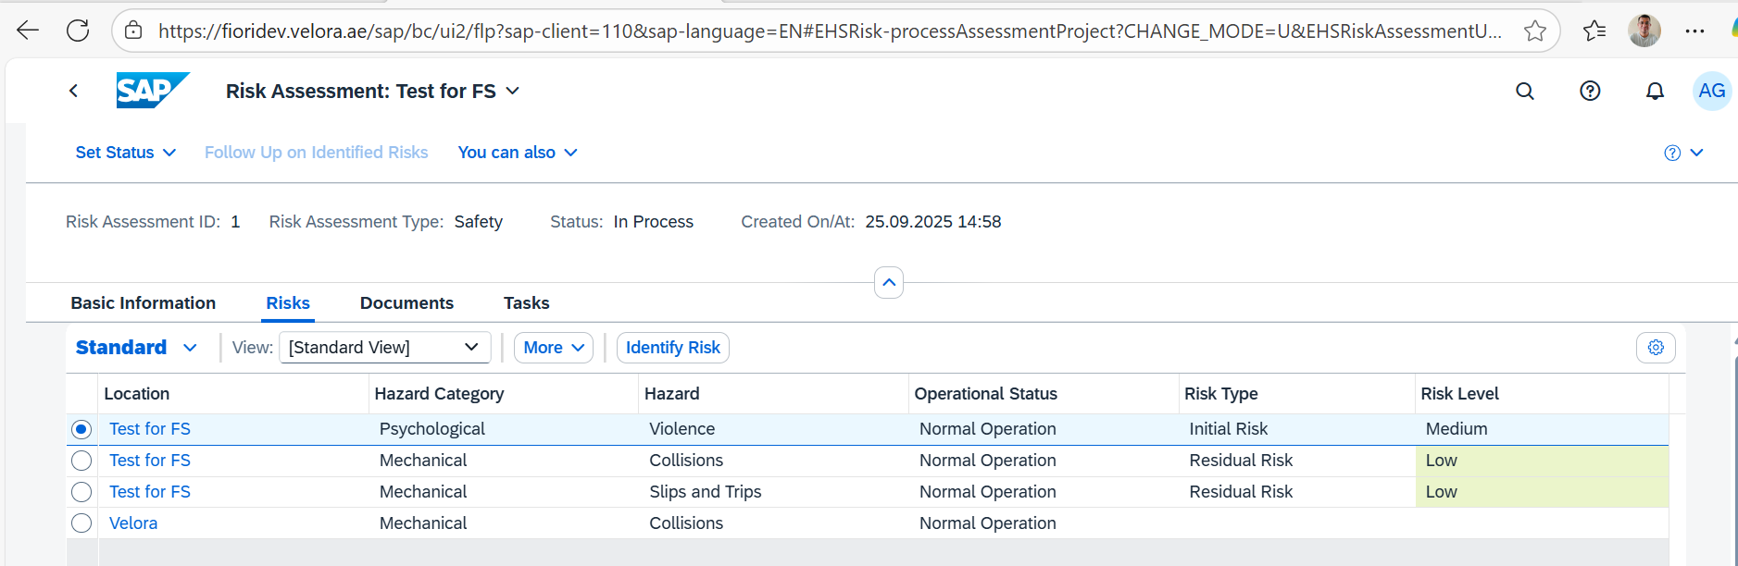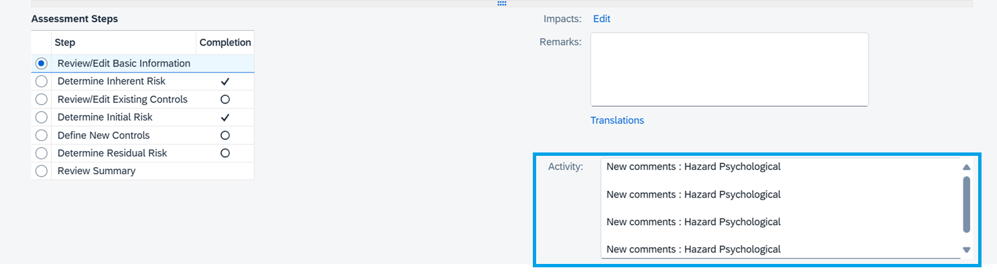
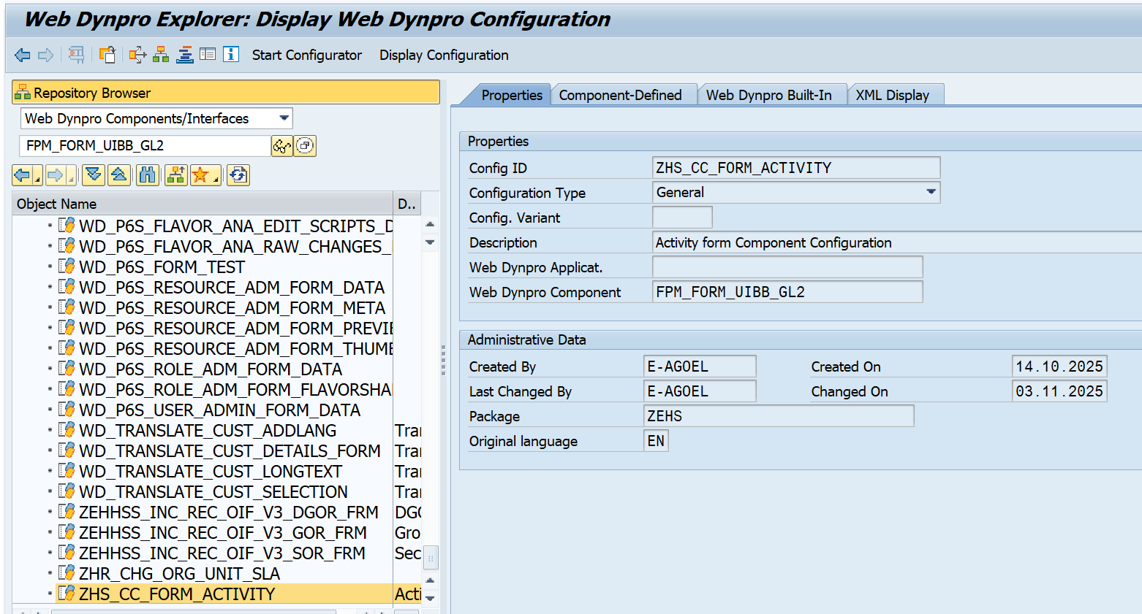
Form feeder class
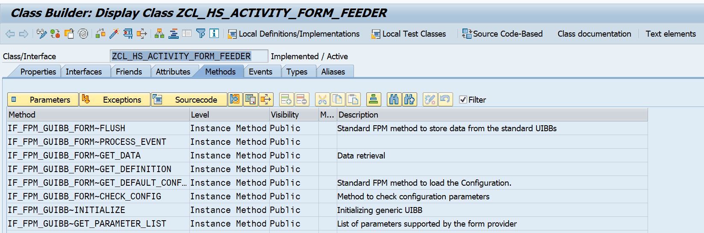
Get data method to retrieve the data
METHOD if_fpm_guibb_form~get_data.
DATA:ls_activity_comments TYPE zhs_s_activity_comments,
lv_risk_root_key TYPE /bobf/conf_key,
lv_tdobjectname TYPE tdobname.
DATA:lt_key TYPE /bobf/t_frw_key,
lt_link TYPE /bobf/t_frw_key_link,
lt_revision_key TYPE /bobf/t_frw_key,
lt_failed_key TYPE /bobf/t_frw_key,
lt_lines TYPE tline_t,
lo_tra_mgr TYPE REF TO /bobf/if_tra_service_manager,
lo_message TYPE REF TO /bobf/if_frw_message.
CONSTANTS:lc_parameter_id TYPE tdid VALUE 'ZACT',
lc_tdobject TYPE tdobject VALUE 'ZACTV_TXT'.
"Get Risk root key
io_event->mo_event_data->get_value( EXPORTING iv_key = 'RISKKEY'
IMPORTING ev_value = lv_risk_root_key ).
IF lv_risk_root_key IS NOT INITIAL.
"Get the risk revision DB key from Risk root key
lo_tra_mgr = /bobf/cl_tra_serv_mgr_factory=>get_service_manager( EXPORTING iv_bo_key = if_ehhss_rsk_c=>sc_bo_key ).
IF lo_tra_mgr IS BOUND.
lt_key = VALUE #( ( key = lv_risk_root_key ) ).
lo_tra_mgr->retrieve_by_association( EXPORTING iv_node_key = if_ehhss_rsk_c=>sc_node-root
it_key = lt_key
iv_association = if_ehhss_rsk_c=>sc_association-root-revision
iv_fill_data = abap_false
iv_edit_mode = /bobf/if_conf_c=>sc_edit_read_only
IMPORTING eo_message = lo_message
et_key_link = lt_link
et_target_key = lt_revision_key
et_failed_key = lt_failed_key ).
IF lt_revision_key IS NOT INITIAL.
lv_tdobjectname = lt_revision_key[ 1 ]-key.
CALL FUNCTION 'READ_TEXT'
EXPORTING
client = sy-mandt
id = lc_parameter_id
language = sy-langu
name = lv_tdobjectname
object = lc_tdobject
TABLES
lines = lt_lines
EXCEPTIONS
id = 1
language = 2
name = 3
not_found = 4
object = 5
reference_check = 6
wrong_access_to_archive = 7
OTHERS = 8.
IF sy-subrc <> 0.
* Implement suitable error handling here
ENDIF.
LOOP AT lt_lines ASSIGNING FIELD-SYMBOL(<lfs_lines>).
CONCATENATE ls_activity_comments-activity_comments <lfs_lines>-tdline cl_abap_char_utilities=>newline
INTO ls_activity_comments-activity_comments.
ENDLOOP.
ls_activity_comments-risk_key_guid = lv_risk_root_key.
cs_data = ls_activity_comments.
ev_data_changed = abap_true.
ENDIF.
ENDIF.
ENDIF.
ENDMETHOD.
To store the current user provided data in the activity field for save action
METHOD if_fpm_guibb_form~flush.
FIELD-SYMBOLS:<lfs_activity_comments> TYPE zhs_s_activity_comments.
CLEAR:gs_activity_comments_ui.
IF is_data IS NOT INITIAL.
ASSIGN is_data->* TO <lfs_activity_comments>.
ASSIGN COMPONENT 'ACTIVITY_COMMENTS' OF STRUCTURE <lfs_activity_comments> TO FIELD-SYMBOL(<lfs_updated_comments>).
IF <lfs_updated_comments> IS ASSIGNED.
gs_activity_comments_ui-activity_comments = <lfs_updated_comments>.
ENDIF.
ASSIGN COMPONENT 'RISK_KEY_GUID' OF STRUCTURE <lfs_activity_comments> TO FIELD-SYMBOL(<lfs_risk_key_guid>).
IF <lfs_risk_key_guid> IS ASSIGNED.
gs_activity_comments_ui-risk_key_guid = <lfs_risk_key_guid>.
ENDIF.
ENDIF.
ENDMETHOD.

To save the data in the db table
METHOD if_fpm_guibb_form~process_event.
DATA:ls_header TYPE thead,
lv_tdobjectname TYPE tdobname,
lv_risk_root_key TYPE /bobf/conf_key,
lt_lines TYPE tline_t,
lt_ui_text TYPE STANDARD TABLE OF string.
DATA:lt_key TYPE /bobf/t_frw_key,
lt_link TYPE /bobf/t_frw_key_link,
lt_revision_key TYPE /bobf/t_frw_key,
lt_failed_key TYPE /bobf/t_frw_key,
lo_tra_mgr TYPE REF TO /bobf/if_tra_service_manager,
lo_message TYPE REF TO /bobf/if_frw_message.
DATA:lo_fpm TYPE REF TO if_fpm,
lo_message_manager TYPE REF TO if_fpm_message_manager.
CONSTANTS:lc_parameter_id TYPE tdid VALUE 'ZACT',
lc_tdobject TYPE tdobject VALUE 'ZACTV_TXT'.
CASE io_event->mv_event_id.
WHEN if_fpm_constants=>gc_event-save.
"Prepare activity text for insert/update
IF gs_activity_comments_ui IS NOT INITIAL.
SPLIT gs_activity_comments_ui-activity_comments AT cl_abap_char_utilities=>newline INTO TABLE lt_ui_text.
IF lt_ui_text IS NOT INITIAL.
lt_lines = VALUE #( FOR ls_ui_text IN lt_ui_text
( tdformat = '*'
tdline = ls_ui_text ) ).
ENDIF.
ENDIF.
IF lt_lines IS INITIAL.
lt_lines = VALUE #( ( tdformat = '*' tdline = '' ) ).
ENDIF.
"Get the risk revision DB key from Risk root key
lo_tra_mgr = /bobf/cl_tra_serv_mgr_factory=>get_service_manager( EXPORTING iv_bo_key = if_ehhss_rsk_c=>sc_bo_key ).
IF lo_tra_mgr IS BOUND.
lt_key = VALUE #( ( key = gs_activity_comments_ui-risk_key_guid ) ).
lo_tra_mgr->retrieve_by_association( EXPORTING iv_node_key = if_ehhss_rsk_c=>sc_node-root
it_key = lt_key
iv_association = if_ehhss_rsk_c=>sc_association-root-revision
iv_fill_data = abap_false
iv_edit_mode = /bobf/if_conf_c=>sc_edit_read_only
IMPORTING eo_message = lo_message
et_key_link = lt_link
et_target_key = lt_revision_key
et_failed_key = lt_failed_key ).
ENDIF.
IF lt_lines IS NOT INITIAL AND lt_revision_key IS NOT INITIAL.
lv_tdobjectname = lt_revision_key[ 1 ]-key.
ls_header-tdid = lc_parameter_id.
ls_header-tdobject = lc_tdobject.
ls_header-tdname = lv_tdobjectname.
ls_header-tdspras = sy-langu.
CALL FUNCTION 'SAVE_TEXT'
EXPORTING
client = sy-mandt
header = ls_header
savemode_direct = abap_true
TABLES
lines = lt_lines
EXCEPTIONS
id = 1
language = 2
name = 3
object = 4
OTHERS = 5.
IF sy-subrc NE 0.
APPEND INITIAL LINE TO et_messages ASSIGNING FIELD-SYMBOL(<lfs_message>).
IF <lfs_message> IS ASSIGNED.
<lfs_message>-msgid = sy-msgid.
<lfs_message>-msgno = sy-msgno.
<lfs_message>-severity = sy-msgty.
<lfs_message>-parameter_1 = sy-msgv1.
<lfs_message>-parameter_2 = sy-msgv2.
<lfs_message>-parameter_3 = sy-msgv3.
<lfs_message>-parameter_4 = sy-msgv4.
ENDIF.
ev_result = if_fpm_constants=>gc_event_result-failed.
ELSE.
ev_result = if_fpm_constants=>gc_event_result-ok.
lo_fpm = cl_fpm_factory=>get_instance( ).
IF lo_fpm IS BOUND.
lo_fpm->mo_message_manager->report_message_toast( iv_message_text = TEXT-001 ).
ENDIF.
ENDIF.
ENDIF.
ENDCASE.
ENDMETHOD.

